|  |  |  |
| --- | --- | --- |
| **Module Name:** | Login Page |  |
| **Test Case ID:** | TEST1 |  |
| **Tester Name:** | Shani Tiwari |  |
| **Test Case Description:** | Bank website test |  |
| **Prerequisites:** | 1.Stable internet connection |  |
|  | 2.Browser(All) |  |
| **Environment Information:** | 1.OS: Windows/Linux/Mac |  |
| 2.System: Laptop/Desktop |  |

Checking Creditionals

1.Open Bank Site  
2login  
  
Checking Account Balance  
1.Enter Password  
  
Money Transfer invalid info

Valid

1.Enter

1.Enter Receiver Name

2.Show Receiver Profile

3.Name

4.Last Name

5.Email

6.Phone Number

7Click to Send Payment

8.Enter Amount

9.click  
  
Check Transaction History

1.Click to check

2.check transaction  
  
  
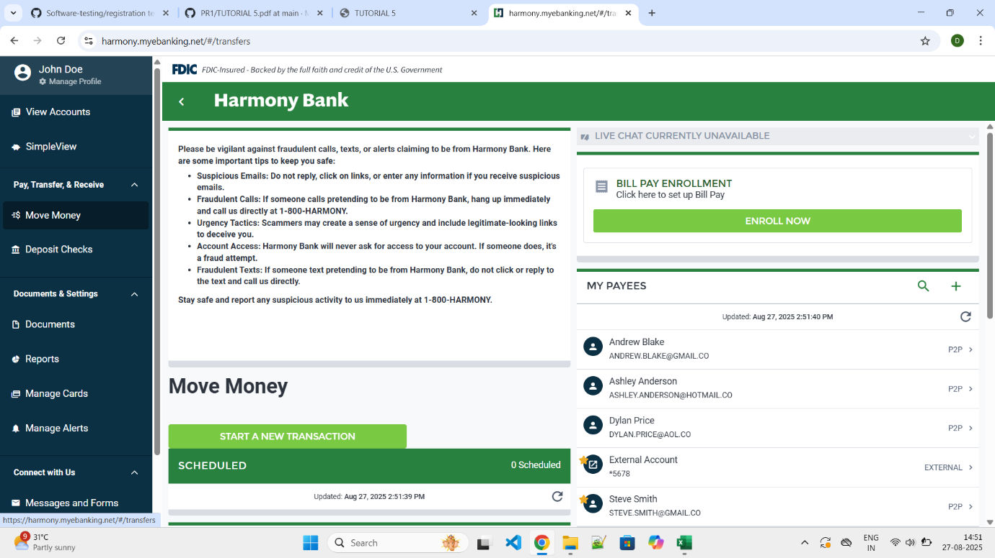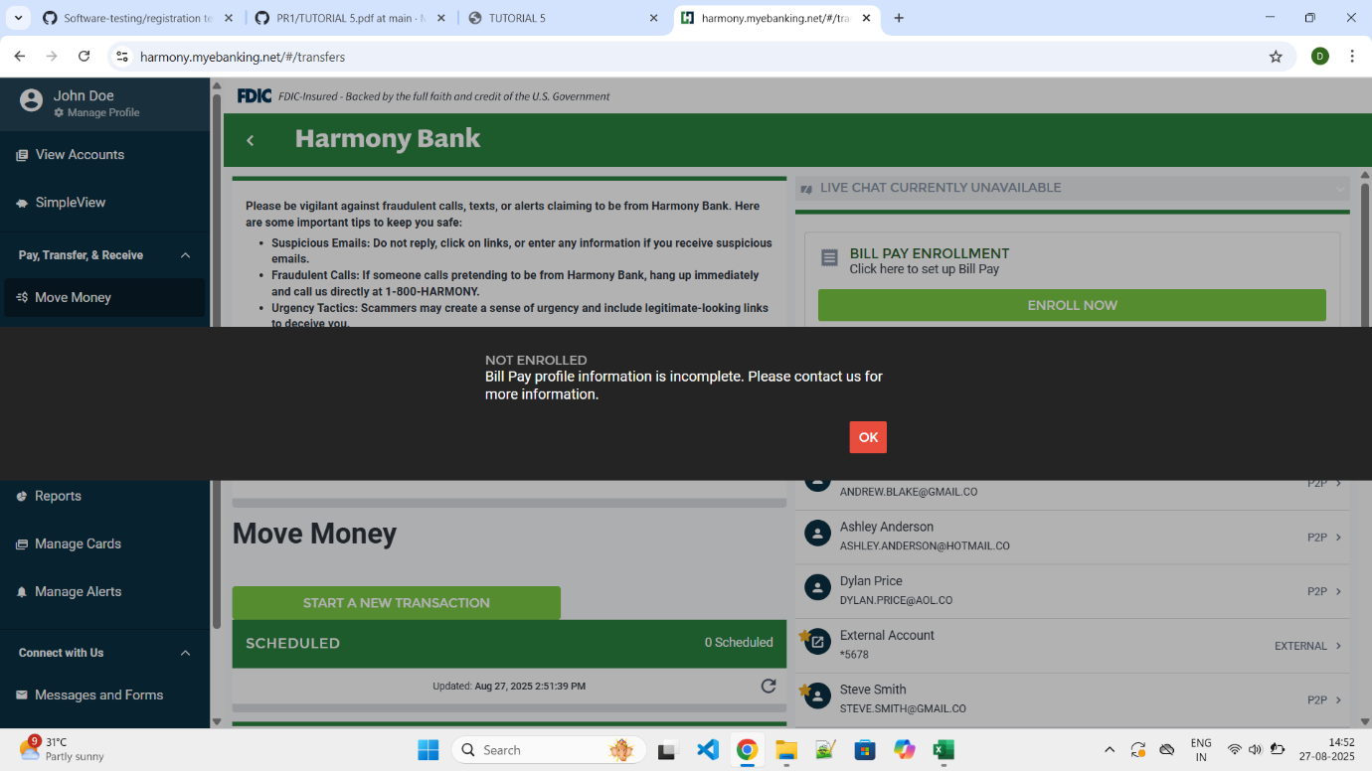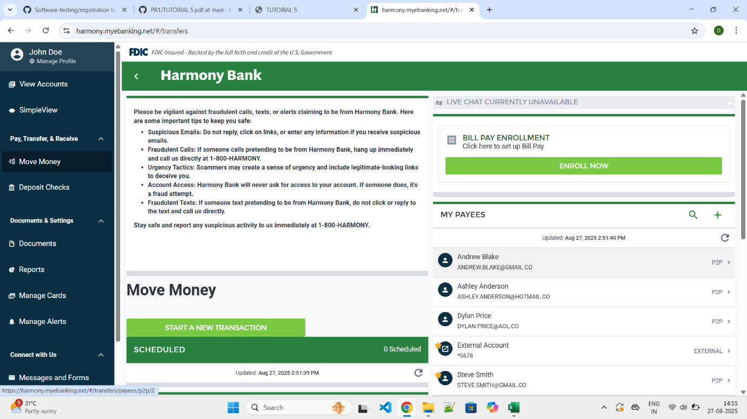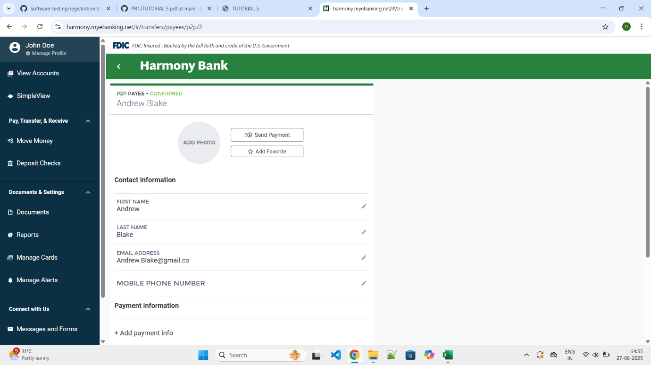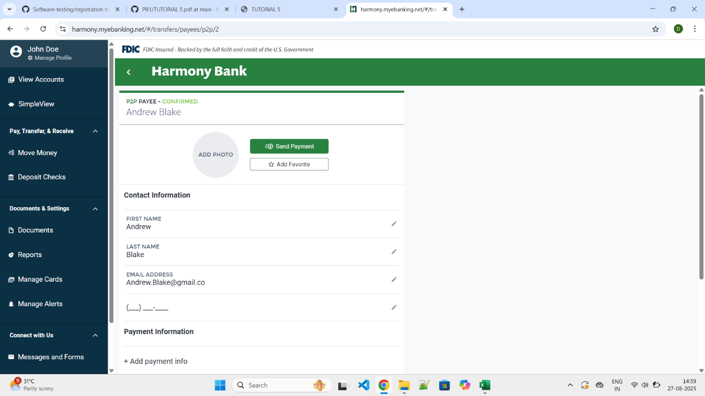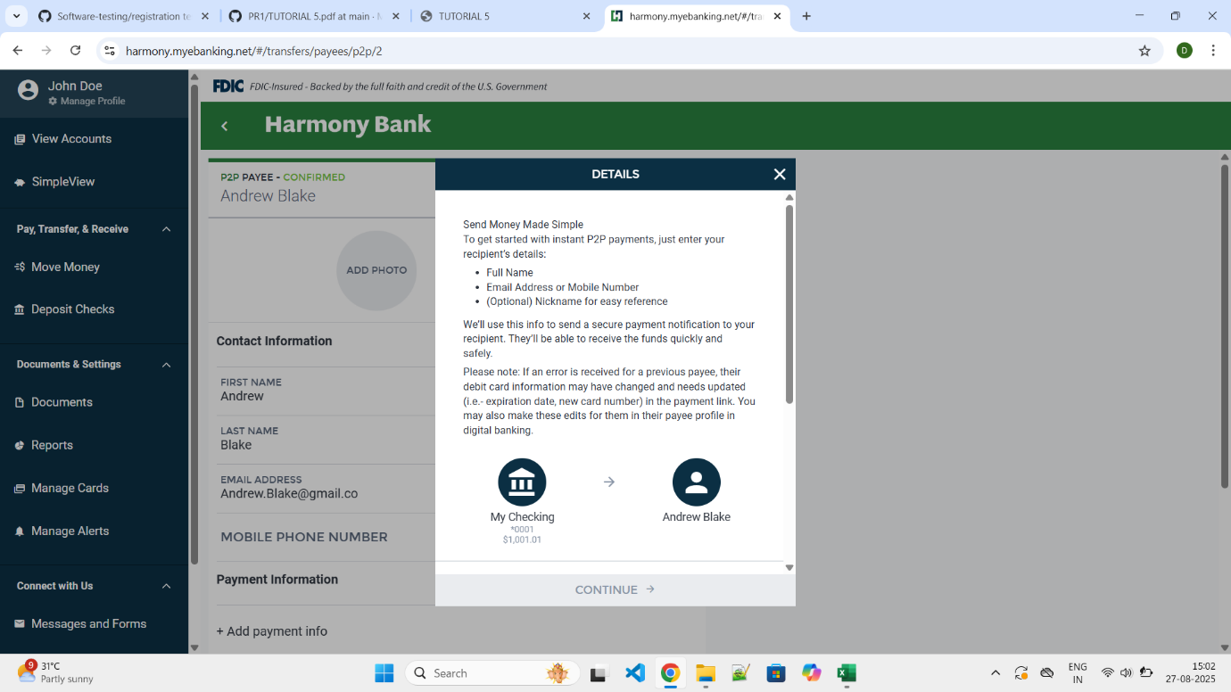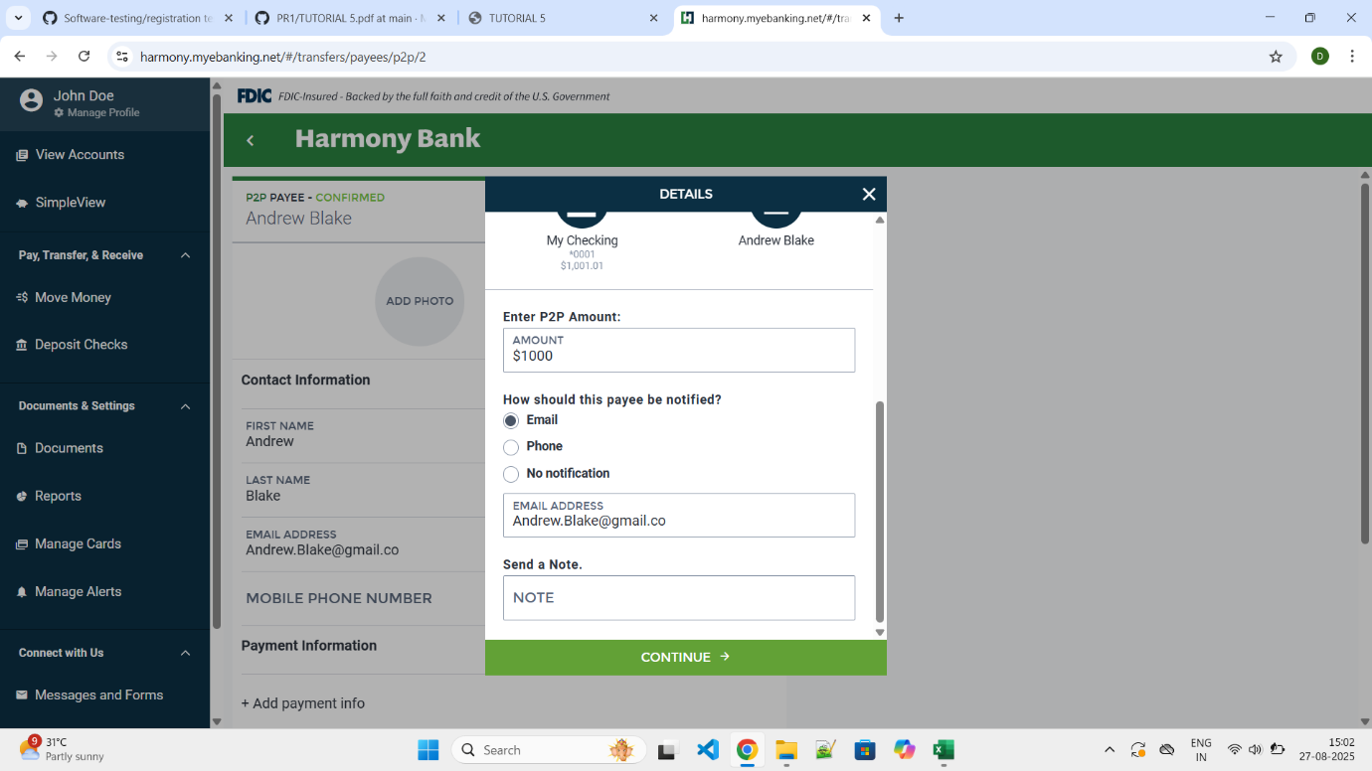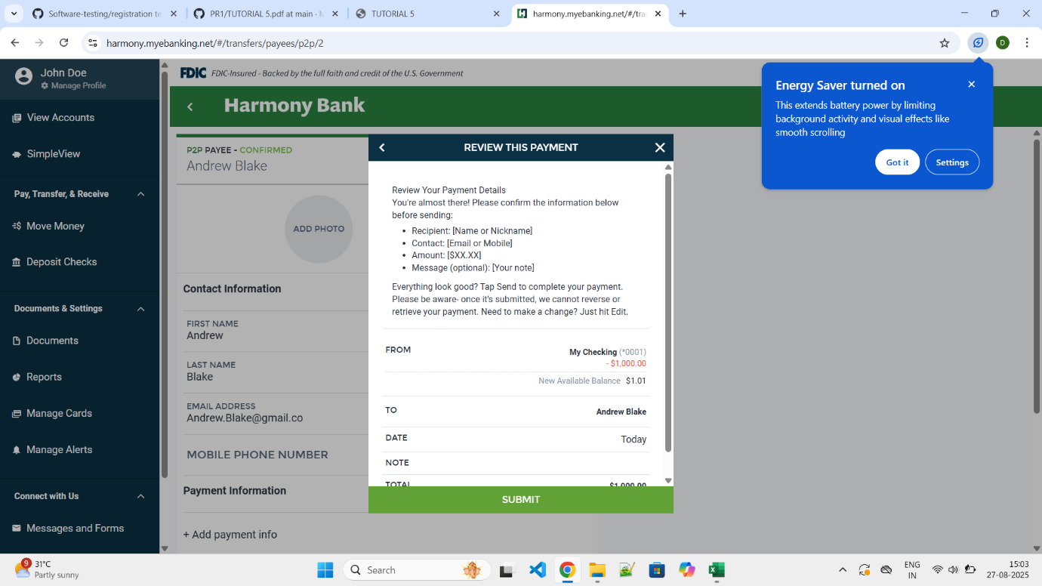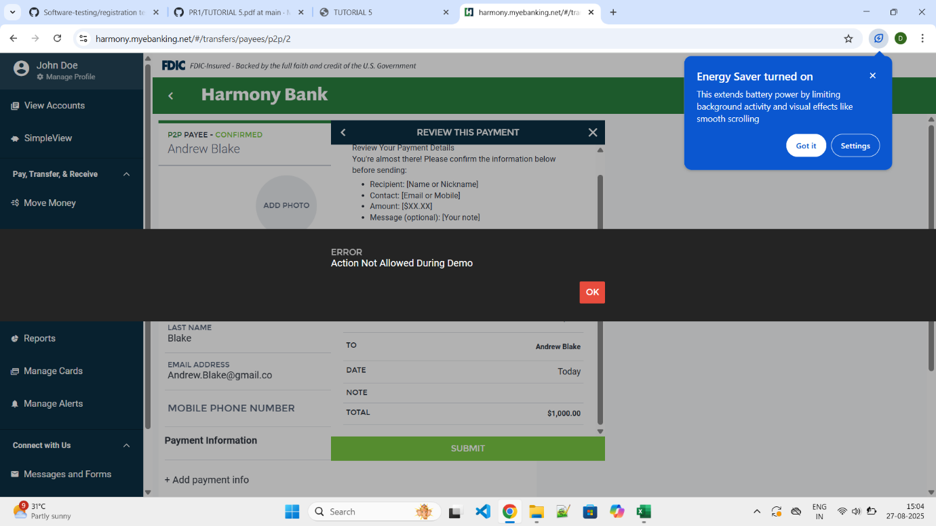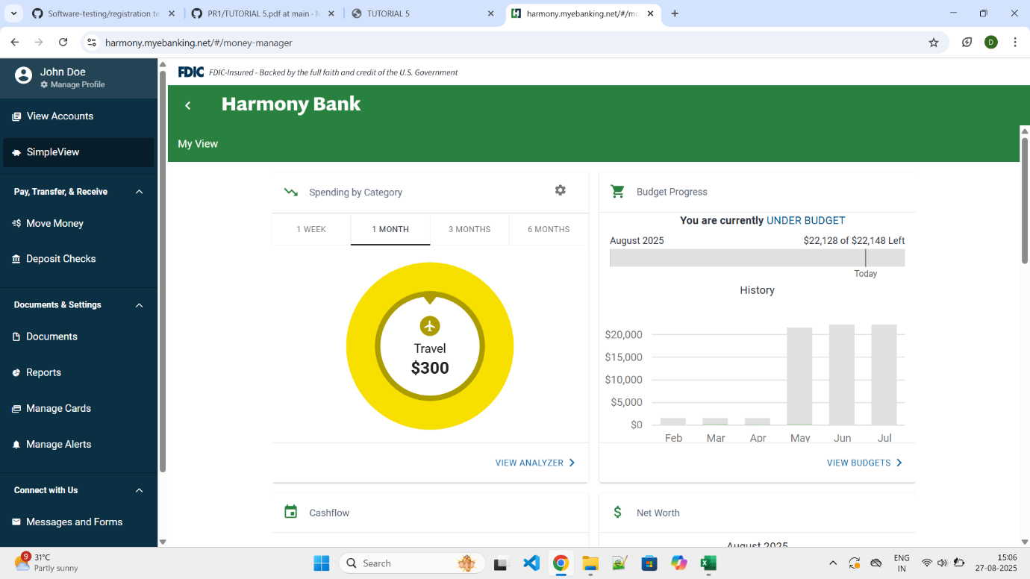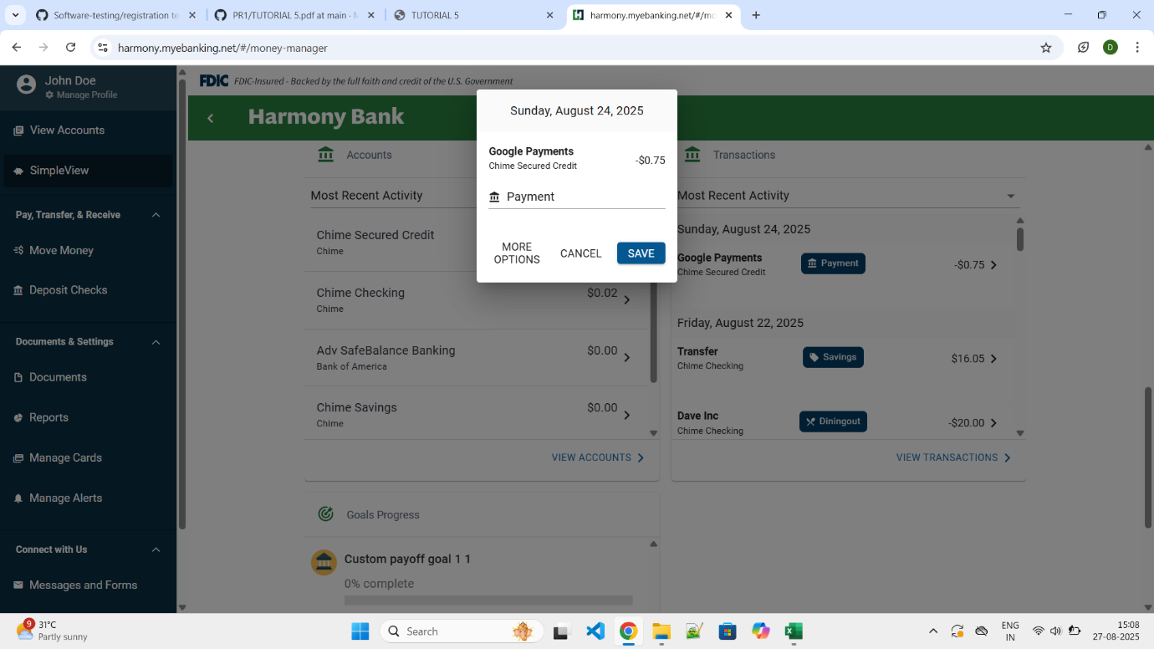  
  
  
Summary Of Test Results:   
Total Test Cases- 15 Passed- 11 Failed- 9 Pass %- 73.33%   
● Conclusion and Recommendations: Pass Rate: 73.33%, Need Improvement  
● Issues Found 4  
Bug Reports:   
1. Field Description Bug ID BUG-5  
 1. Send automatic to Page not Asking Password  
2. Not taking phone number Input  
3. On the Time of transfer Not Transfer money  
4. Again not asking detail and give access